**Examples of Disk Scheduling Algorithms**

* **Work Queue**: 23, 89, 132, 42, 187
* there are 200 cylinders numbered from 0 - 199
* the diskhead stars at number 100

1. **FCFS** 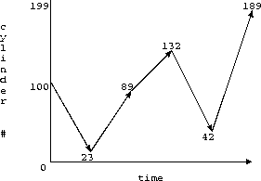

* total time is estimated by total arm motion   
  http://www2.cs.uregina.ca/~hamilton/courses/330/notes/io/img10.gif

1. **SSTF** 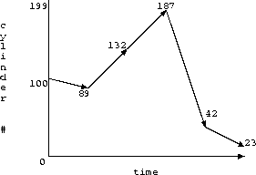

http://www2.cs.uregina.ca/~hamilton/courses/330/notes/io/img12.gif

1. **SCAN**
   * assume we are going inwards (i.e., towards 0)

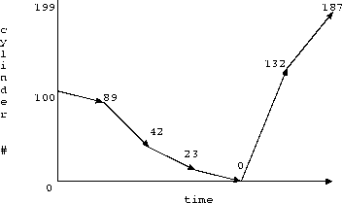

http://www2.cs.uregina.ca/~hamilton/courses/330/notes/io/img14.gif

1. **LOOK**

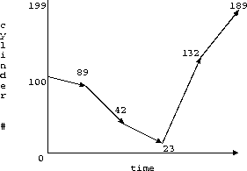

http://www2.cs.uregina.ca/~hamilton/courses/330/notes/io/img16.gif

* + reduce variance compared to SCAN

1. **C-SCAN**

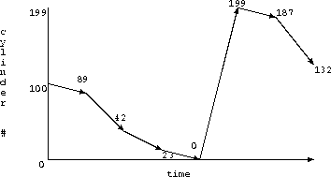

http://www2.cs.uregina.ca/~hamilton/courses/330/notes/io/img18.gif

1. **C-LOOK**

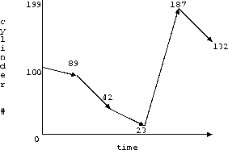

http://www2.cs.uregina.ca/~hamilton/courses/330/notes/io/img20.gif